1)use case

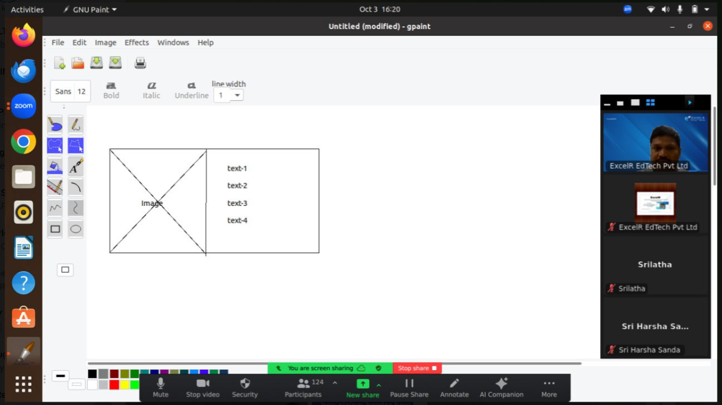

Rwd1.html

<!DOCTYPE html>

<html>

<head>

<title>SASS with media</title>

<link rel="stylesheet" href="rwd1.css">

</head>

<body>

<div class ="container">

<div class="container__img">

</div>

<div class="container__text">

<p class="container__text__1">Hello i am from KLuniversity 👋👋👋</p>

<p class="container__text__2">Computer department👋👋</p>

<p class="container__text__3">Amaravathi👋👋</p>

<p class="container__text__4">Ap👋👋</p>

</div>

</div>

</body>

</html>

Rwd1.scss

*{

padding: 0px;

margin: 0px;

box-sizing: border-box;

}

.container{

height: 100vh;

display:flex;

&__img{

flex: 1;

background-image: url("./logo.png");

background-repeat: no-repeat;

background-position: center center ;

}

&__text{

flex: 1;

border: 1px solid green;

display: flex;

justify-content: center;

flex-direction: column;

align-items: center;

&__1{

font-size: 2.5rem;

}

[class^="container__text__"]{

font-size: 1.5rem;

}

}

}

Updated code:

$mobile :567px;

*{

padding: 0px;

margin: 0px;

box-sizing: border-box;

}

.container{

height: 100vh;

display:flex;

&__img{

flex: 1;

background-image: url("./logo.png");

background-repeat: no-repeat;

background-position: center center ;

}

&__text{

flex: 1;

display: flex;

justify-content: center;

flex-direction: column;

align-items: center;

&__1{

font-size: 2.5rem;

}

[class^="container__text__"]{

font-size: 1.5rem;

}

}

}

@media(max-width:$mobile){

.container{

flex-direction: column;

&__img{

}

&__text{

[class^="container__text__"]:not(.container__text__1){

display: none;

}

&__1{

font-size: 2rem;

}

}

}

}

Bootstrap

-------------

Bootstrap is the CSS framework

By default, responsive

We will use for responsive web design

Bootstrap CDN has to be included in the Header section of web page.

Current version Bootstrap5.X(released by twitter)

Colors:

---------

1. Primary
2. Success
3. Danger
4. Warning
5. Secondary
6. Light
7. Dark

Bootstrap cdn URL

<link rel="stylesheet" href="<https://cdn.jsdelivr.net/npm/bootstrap@4.6.2/dist/css/bootstrap.min.css>" integrity="sha384-xOolHFLEh07PJGoPkLv1IbcEPTNtaed2xpHsD9ESMhqIYd0nLMwNLD69Npy4HI+N" crossorigin="anonymous">

In bootstrap we have container

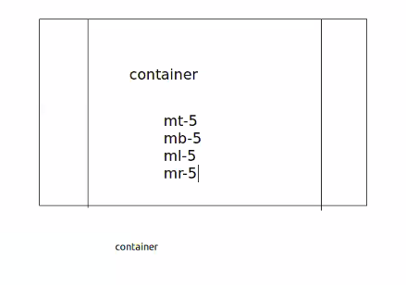

Mt-margintop

Mb-marginbottem

ml-marginleft

Mr-marginright

**Bootstrap.html**

<!DOCTYPE html>

<html>

<head>

<title>

</title>

<link rel="stylesheet" href="https://cdn.jsdelivr.net/npm/bootstrap@4.6.2/dist/css/bootstrap.min.css" integrity="sha384-xOolHFLEh07PJGoPkLv1IbcEPTNtaed2xpHsD9ESMhqIYd0nLMwNLD69Npy4HI+N" crossorigin="anonymous">

</head>

<body>

<div class="container mt-5"></div>

<h1 class="text text-primary bg-success">Hello</h1>

<h1 class="text text-success bg-danger">Hello</h1>

<h1 class="text text-secondary bg-primary">Hello</h1>

<h1 class="text text-warning bg-secondary" >Hello</h1>

<h1 class="text text-danger bg-light">Hello</h1>

<h1 class="text text-light bg-dark">Hello</h1>

<h1 class="text text-dark bg-light">Hello</h1>

</body>

</html>

<https://getbootstrap.com/docs/5.3/components/buttons/>

Usecase:

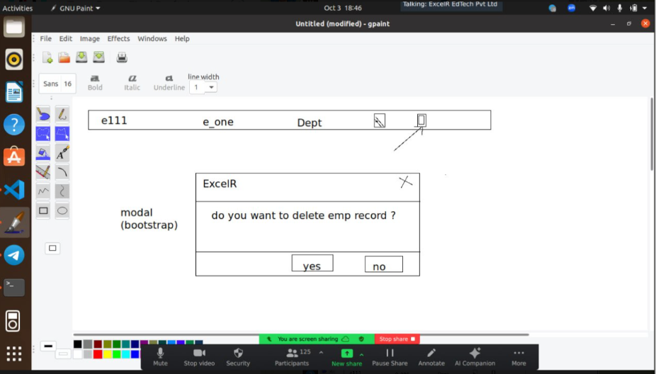

To build this we have MODAL class- under modal

we have child class- modal-dialog

child class- modal-content

modal-header

modal-title

close &times; X symbol

modal-body

modal-footer

To close popup jquery is needed data-toggle = ”dismiss”

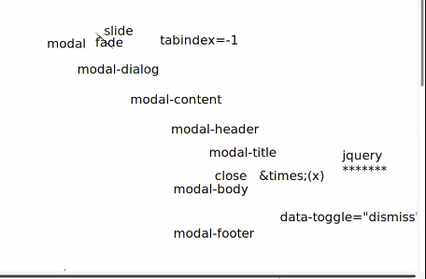

To blur background: **tabindex=-1**

**Animation to apply using class called – Fade class**

**Use case code:**

**Modal.html**

**---------------**

<!DOCTYPE html>

<html lang="en">

<head>

<meta charset="UTF-8">

<meta name="viewport" content="width=device-width, initial-scale=1.0">

<title>Document</title>

<link rel="stylesheet" href="https://cdn.jsdelivr.net/npm/bootstrap@4.6.2/dist/css/bootstrap.min.css">

<script src="https://cdn.jsdelivr.net/npm/jquery@3.7.1/dist/jquery.slim.min.js"></script>

<script src="https://cdn.jsdelivr.net/npm/popper.js@1.16.1/dist/umd/popper.min.js"></script>

<script src="https://cdn.jsdelivr.net/npm/bootstrap@4.6.2/dist/js/bootstrap.bundle.min.js"></script>

</head>

<body>

<div class="container mt-5">

<button class="btn btn-success" data-toggle="modal" data-target="#id1">Button</button>

<div id="id1" class="modal fade" tabindex="-1">

<div class="modal-dialog">

<div class="modal-content">

<div class="modal-header">

<h5 class="modal-title">KLUniv</h5>

<button class="close" data-dismiss="modal">

<span>&times;</span>

</button>

</div>

<div class="modal-body">

<p>do you want to edit record ?</p>

</div>

<div class="modal-footer">

<button class="btn btn-success btn-sm">Yes</button>

<button class="btn btn-danger btn-sm" data-dismiss="modal">No</button>

</div>

</div>

</div>

</div>

</div>

</body>

</html>

**Offcial website**

**Getbootstrap.com**

**JQUERY CDN**

<link rel="stylesheet" href="<https://cdn.jsdelivr.net/npm/bootstrap@4.6.2/dist/css/bootstrap.min.css>"> <script src="<https://cdn.jsdelivr.net/npm/jquery@3.7.1/dist/jquery.slim.min.js>"></script> <script src="<https://cdn.jsdelivr.net/npm/popper.js@1.16.1/dist/umd/popper.min.js>"></script> <script src="<https://cdn.jsdelivr.net/npm/bootstrap@4.6.2/dist/js/bootstrap.bundle.min.js>"></script>